Paul Kafka

10/28/13

Embedded Micro System Design

**Homework 6**

**Top Level BDF Graphic**

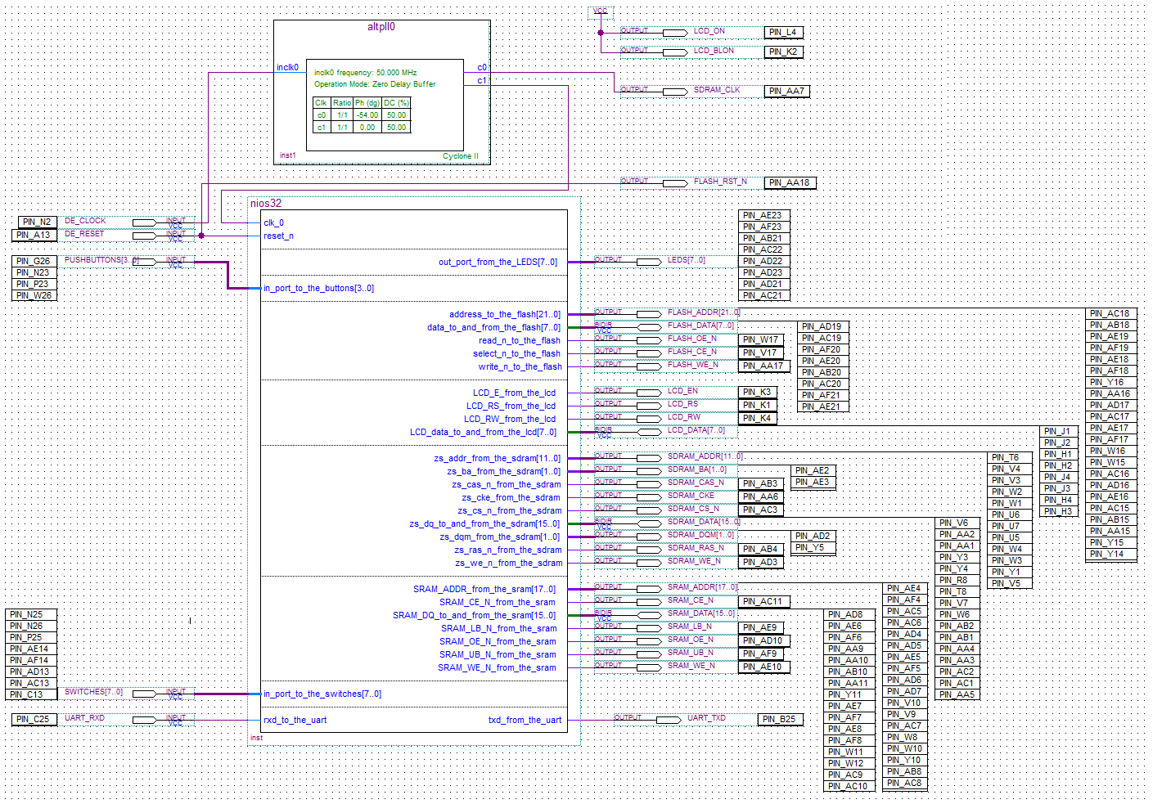

**SPOC Snapshot**

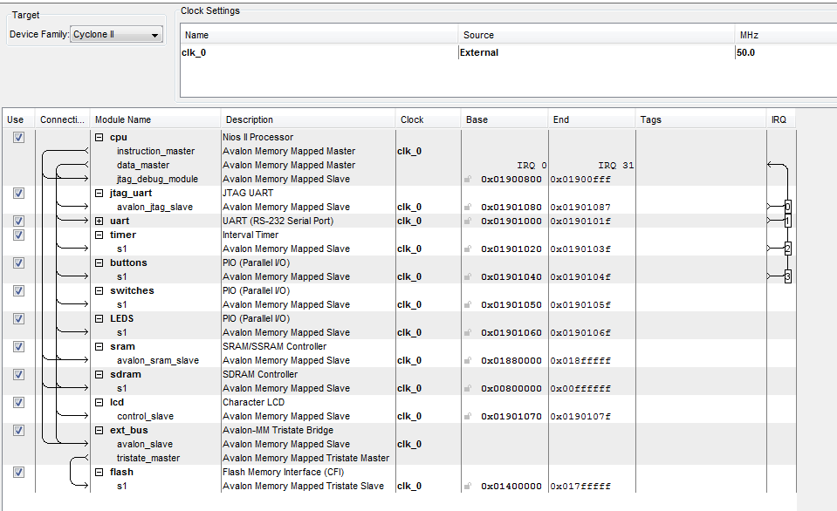

**Resource Data**

